Table of Contents

1. Introduction to GPT-4 Chatbots

- Objective

- What is a Chatbot?

- The Evolution to GPT-4

- Capabilities of GPT-4 Chatbots

- Value of GPT-4 Chatbots

- Applications of GPT-4 Chatbots

2. Setting Up GPT-4 in an Enterprise Environment

- Objective

- Enterprise OpenAI Account Setup

- API Key Access

- API Quotas and Usage

- Team and Permissions

- Compliance and Security

3. Setting Up Your Development Environment

- Objective

- Software and Tools Installation

- Environment Configuration

- Development Tools

- Access Control and Security Measures

- Collaboration and Workflow Integration

4. Basics of Conversational AI and State Management

- Objective

- Conversational AI Components

- State Management in Conversations

5. Customizing GPT-4 Powered Chatbots

- Objective

- Customizing Responses with GPT-4 Parameters

- Implementing Custom Prompts and Role-Playing

- Ensuring Coherent and Contextual Interactions

6. Fine-Tuning GPT-4 with Organizational Documents

- Objective

- Importance of Fine-Tuning

- Preparing Your Documents

- The Fine-Tuning Process

- Integrating Fine-Tuned Models

- Monitoring and Updating

7. Preparing Organizational Documents for GPT-4 Fine-Tuning

- Objective

- Document Selection

- Document Conversion

- Data Cleaning

- Data Structuring

- Tools and Resources

- Best Practices and Tips

- Compliance and Security

- Feedback and Continuous Improvement

8. Initiating the GPT-4 Fine-Tuning Process

- Objective

- Creating a Dataset

- Uploading the Dataset

- Configuring Fine-Tuning Parameters

- Initiating the Fine-Tuning Process

- Evaluating the Model

- Troubleshooting and Support

9. Incorporating the Fine-Tuned Model into Your Chatbot

- Objective

- Integration Preparation

- Updating API Calls

- Response Handling

- Testing Post-Integration

- Monitoring and Iteration

- Training and Knowledge Transfer

- Documentation Update

- User Engagement and Feedback

10. Enhancing Chatbot Capabilities with Document Uploads

- Objective

- Front-End Setup

- Backend Configuration

- Processing Uploaded Documents

- Integrating with GPT-4

- Response and Storage

- User Engagement and Support

- Continuous Improvement Cycle

11. Integrating Document Data with GPT-4 for Informed Responses

- Objective

- Data Extraction and Formatting

- Augmenting GPT-4 with Anthropic

- Update Conversation Context

- Tailor GPT-4 Prompts

- Validate and Enhance Responses

- User Confirmation and Engagement

12. Validating Chatbot Responses Informed by Uploaded Documents

- Objective

- Establish Validation Criteria

- Response Correction Mechanism

- Feedback Loop for Continuous Learning

- User Confirmation

- Analytics and Reporting

13. Streamlining Chatbot Conversations with Document Data

- Objective

- Contextual Relevance

- Response Generation Optimization

- User Experience Considerations

- Performance Metrics

- Iterative Refinement

14. Enhancing User Experience in Document-Enhanced Chatbot Interactions

- Objective

- Simplify Data Presentation

- Interactive Response Elements

- Personalized Responses

- Clarification and Follow-Up

- User Feedback Collection

- Scalability Considerations

15. Deploying Your Document-Enhanced Chatbot

- Objective

- Pre-Deployment Checklist

- Choose a Deployment Platform

- Set Up Your Deployment Environment

- Monitor and Optimize Performance

- User Engagement and Feedback

- Continuous Improvement Cycle

16. Continuous Improvement of Your Document-Enhanced Chatbot

- Objective

- Establish Key Metrics

- Collect and Analyze Data

- User Feedback Mechanism

- Iterate Based on Insights

- Update and Test

- Training and Knowledge Sharing

Chapter 1: Introduction to GPT-4 Chatbots

Harnessing the power of GPT-4 for conversational AI involves understanding its capabilities and how it can be leveraged to enhance user interactions. In this chapter, we delve into the basics of chatbots, the evolution of the technology leading up to GPT-4, and the value they bring to various applications.

* 1. **What is a Chatbot?**
     + **Definition: A chatbot is a software application designed to simulate human conversation. It can chat with a user in a natural language like English, through messaging applications, websites, mobile apps, or over the phone.**
     + **How it Works: Chatbots interact with users based on a set of predefined rules or artificial intelligence to interpret and respond to user inputs.**

* 1. **The Evolution to GPT-4**
     + **Overview: GPT-4, the fourth iteration of OpenAI's Generative Pre-trained Transformer models, stands at the forefront of natural language processing technology. It can generate text that closely resembles human-written text.**
     + **Advancements: Compared to its predecessors, GPT-4 offers improved text generation, comprehension, and is capable of more nuanced interactions.**

# Pseudo-code demonstrating how to use GPT-4 API

import openai

openai.api\_key = 'your-api-key-here'

response = openai.Completion.create(

engine="davinci-codex", # Assuming GPT-4 engine is named 'davinci-codex'

prompt="Translate the following English text to French: 'Hello, how are you?'",

max\_tokens=60

)

print(response.choices[0].text.strip())

nderstanding 
Text Generation 
Learning Efficiency 
Knowledge Range 
Adaptability 

* 1. **Capabilities of GPT-4 Chatbots**
     + **Multilingual Support: GPT-4 chatbots can understand and communicate in multiple languages, making them accessible to a global audience.**
     + **Personalization: These chatbots can learn from past interactions to provide more personalized responses.**

* 1. **Value of GPT-4 Chatbots**
     + **Efficiency: Automate responses to common inquiries, allowing human agents to focus on more complex issues.**
     + **Insights & Analytics: They can analyze conversations to gain insights into user behavior and preferences, which can help shape business strategies.**

* 1. **Applications**
     + **Use Cases: GPT-4 chatbots can be employed in various sectors such as customer service, personal assistance, education, and therapy, enhancing the user experience across different platforms including websites, social media, and messaging apps.**



Chapter 2: Setting Up GPT-4 in an Enterprise Environment

Integrating GPT-4 into an enterprise environment requires careful planning and adherence to specific protocols. This chapter outlines the essential steps and considerations for a successful setup, from creating an OpenAI account to understanding compliance and security measures.

* 1. **Enterprise OpenAI Account Setup**

• Introduction: To commence the integration of GPT-4, your organization needs to establish an enterprise account with OpenAI. This type of account offers enhanced features, support, and API access, customizing the experience to suit your business needs.

# Pseudo-code to demonstrate account setup (API Initialization)

import openai

openai.api\_key = 'your-enterprise-api-key-here'

* 1. **API Key Access**

• Importance: Obtaining an API key is a critical step, as it facilitates authentication and access to the GPT-4 API. It should be procured through your organization's account administrator and managed securely to prevent unauthorized access.

• Security: Ensure that the API keys are stored and handled securely, complying with your organization's IT security protocols.

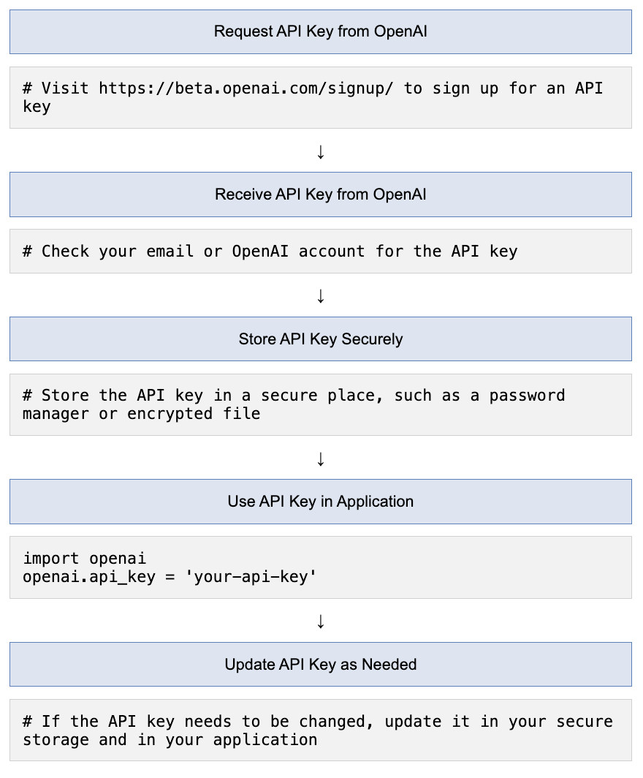

# Pseudo-code to demonstrate API key usage

response = openai.Completion.create(

engine="davinci-codex",

prompt="Sample prompt here",

max\_tokens=50,

api\_key='your-secured-api-key-here' # Use the secured API key here

)

* 1. **API Quotas and Usage**

• Overview: Understanding the quotas and limits on API usage specific to your enterprise account is vital. These parameters often allow for larger scale operations than individual accounts, helping to maintain a balanced load.

• Monitoring: Develop mechanisms to monitor API usage to avoid surpassing the assigned quotas, ensuring uninterrupted service.

# Pseudo-code to check API usage (Hypothetical endpoint)

usage\_info = openai.APIUsage.retrieve()

print(f"API usage: {usage\_info['usage']['total']}/{usage\_info['quota']['total']}")

* 1. **Coordinating Teams and Permissions**

• Team Setup: Coordination with IT or DevOps teams is essential to set appropriate permissions for members needing OpenAI API access. It helps in delineating roles and controlling API usage effectively.

• Security Measures: Implement measures to secure access, thereby preventing potential breaches and unauthorized usage.

API Quota Allocation for Enterprise Account 
Team Member D 
Unallocated 
15.0% 
10.0% 
Team Member C 
20.0% 
30.0% 
Team Member A 
25.0% 
Team Member B 

# Pseudo-code to manage user permissions (Hypothetical function)

def assign\_permission(user, permission\_level):

# Function to assign permission levels to different users

pass

* 1. **Compliance and Security**

• Adherence to Standards: When integrating GPT-4, adherence to the organization's compliance standards concerning data handling, privacy, and security is paramount.

• Regulatory Compliance: Ensure the integration complies with industry-specific regulatory requirements to prevent legal complications.

# Pseudo-code to demonstrate compliance check (Hypothetical function)

def compliance\_check(interaction\_data):

# Function to check if interaction data complies with standards

return "Compliant"

Chapter 3: Setting Up Your Development Environment

Before diving into the integration of GPT-4, it is essential to prepare your development environment appropriately. This chapter guides you through the necessary steps and considerations, including software installation, environment configuration, and the integration of development tools.

* 1. **Software and Tools Installation**

• Essential Tools: To interact with the GPT-4 API, ensure that necessary software such as Python is installed on your development machine. Python is commonly used for scripting and interacting with the API.

• Libraries and SDKs: Install required libraries or SDKs, such as the OpenAI Python library, to facilitate API requests.

Install Python 
Install Libraries 
Configure Environment Variables 
Security Measures 
Use OpenAl 
import openai 
openai.api_key = 
= openai.Completion.create(engine="davinci—codex" , 
response 
prompt:" Translate the following English text to French: 
'Hello, how are you? I", max_tokens=60) 
print ( response. choices [0] . text. strip( ) ) 

* 1. **Environment Configuration**

• Virtual Environment: Set up a virtual environment for your project to manage dependencies effectively and isolate your project's environment from global Python settings.

• Secure Storage: Configure environment variables to securely store and access your OpenAI API key, adhering to your organization's security protocols.

* 1. **Development Tools**

• Choosing an IDE: Select a code editor or Integrated Development Environment (IDE) that aligns with your team's preferences and workflow. Options might include Visual Studio Code, PyCharm, or Jupyter notebooks for exploratory work.

• Version Control: Ensure version control systems, such as Git, are in place for code management, collaboration, and deployment processes.

* 1. **Access Control and Security Measures**

• Access Controls: Implement controls to restrict access to your development environment and protect sensitive data.

• Secure Communication: Utilize encrypted communication channels and secure storage solutions to safeguard data or credentials used during development.

* 1. **Collaboration and Workflow Integration**

• Collaboration Tools: Integrate your development setup with workflow tools and platforms, such as Slack for communication and Trello for task management, to streamline collaboration among your development team.

• CI/CD Pipeline: Establish a continuous integration/continuous deployment (CI/CD) pipeline to automate testing and deployment processes, ensuring smooth and efficient updates and maintenance.

Python, OpenAl Python library 
Virtual Environment, Secure Storage 
IDE (VS code, PyCharm, Jupyter), Git 
Access Controls, Secure Communication 
Slack, Trello, CUCD Pipeline 

Chapter 4: Basics of Conversational AI and State Management

To build effective chatbots with GPT-4, understanding the foundational components of conversational AI and the significance of state management in maintaining a coherent and contextual conversation is essential. This chapter delves into these foundational concepts, offering insights into how GPT-4 manages conversations effectively.

**1. Conversational AI Components**

• Natural Language Understanding (NLU): The component that interprets the user's intent by analyzing the input text, acting as the first step in processing the user's request.

• Natural Language Processing (NLP): This part processes the interpreted data to understand the context and significance of the user's input.

• Natural Language Generation (NLG): The final step where a response is generated based on the chatbot's understanding and processed information.

Natural Language Understanding (NLU) 
Interpreting and understanding human language 
Natural Language Processing (NLP) 
Processing and analyzing language data 
1 
1 
Natural Language Generation (NLG) 
Generating human-like text from data 

# Pseudo-code to demonstrate a simple conversational AI pipeline

def conversational\_ai\_pipeline(user\_input):

nlu\_output = natural\_language\_understanding(user\_input)

nlp\_output = natural\_language\_processing(nlu\_output)

nlg\_output = natural\_language\_generation(nlp\_output)

return nlg\_output

**2. State Management in Conversations**

• Importance: State management maintains the context and flow of a conversation, making it vital for providing relevant and coherent responses.

• Implementation in GPT-4:

- **Session-Based Management:** Utilizes a session ID to track conversation history, allowing the chatbot to recall previous exchanges within a session.

- **Token-Based Context:** Embeds tokens from previous interactions in subsequent requests to provide context for responses.

Session-Based State Management 
Server stores session data to track user interactions. 
Token-Based State Management 
Client holds a token that is used for stateless 
communication with the server. 

# Pseudo-code to demonstrate state management in GPT-4

class GPT4StateManagement:

def \_\_init\_\_(self):

self.session\_id = generate\_session\_id()

self.token\_context = []

def manage\_state(self, user\_input):

self.token\_context.append(user\_input)

# Logic to handle state management based on token context

return generate\_response(self.token\_context)

Chapter 5: Customizing GPT-4 Powered Chatbots

Creating a GPT-4 powered chatbot that aligns with your specific requirements involves customization at various levels. This chapter guides you through different customization options, including modifying response parameters and implementing role-playing scenarios, to create a chatbot that is both engaging and useful.

* 1. **Customizing Responses with GPT-4 Parameters**

• Temperature: The 'temperature' parameter influences the randomness of the generated responses. A lower value makes the chatbot more deterministic, while a higher value introduces variability and creativity. Learn how to adjust this parameter to fine-tune the chatbot's behavior.

# Pseudo-code to demonstrate customization using temperature parameter

response = openai.Completion.create(

engine="davinci-codex",

prompt="Your prompt here",

max\_tokens=50,

temperature=0.7 # Adjust the temperature parameter

)

Effect of Temperature on Response Variability in LLMs like GPT-4 
0.2 
0.5 
0.7 
Temperature 
1.0 
1.2 

*The chart above depicts how adjusting the temperature setting in language models like GPT-4 affects the variability of responses. As the temperature increases, the chart shows a corresponding increase in response variability, indicating that higher temperatures lead to more diverse and less predictable outputs from the model.*

• Max Tokens: The 'max tokens' parameter controls the length of the generated response. Setting this parameter helps in managing the verbosity of the chatbot, ensuring concise and to-the-point answers.

# Pseudo-code to demonstrate customization using max tokens parameter

response = openai.Completion.create(

engine="davinci-codex",

prompt="Your prompt here",

max\_tokens=50 # Set the max tokens parameter to limit response length

)

* 1. **Implementing Custom Prompts and Role-Playing**

• Custom Prompts: Custom prompts guide the chatbot's tone and style of interaction. Learn how to craft prompts that align with the desired interaction style, be it formal, casual, or anywhere in between.

• Role-Playing Scenarios: Implement role-playing scenarios to enhance user engagement. Configure GPT-4 to assume specific personas, creating a more personalized and engaging user experience.

# Pseudo-code to demonstrate role-playing scenario implementation

prompt = "You are a friendly and helpful virtual assistant."

response = openai.Completion.create(

engine="davinci-codex",

prompt=prompt,

max\_tokens=50

)

Friendly and Casual 
"Hey there! 
I'm here to help you with 
whatever you need. Just ask away, and let's 
make this fun!" 
Professional and Formal 
"Good day. How may I assist you with your 
inquiries today? Please provide the 
necessary details for accurate assistance." 
Witty and Humorous 
"Why did the chatbot cross the road? To get 
to the other side of your questions! Fire 
away, and let's crack this nut." 

* 1. **Ensuring Coherent and Contextual Interactions**

• Structuring Data: Focus on meticulous data structuring to fully leverage GPT-4's contextual understanding. Learn the best practices for organizing conversation data to improve the relevance and engagement of responses.

• Continuous Refinement: Implement strategies for continuous refinement based on interaction outcomes, aiming to enhance the chatbot's ability to deliver contextually coherent responses.

Chapter 6: Fine-Tuning GPT-4 with Organizational Documents

To achieve a chatbot that aligns closely with your organization's specific context and requirements, fine-tuning GPT-4 with organizational documents is a crucial step. This chapter provides a detailed guide on how to prepare your documents and fine-tune the GPT-4 model to enhance its relevance and accuracy.

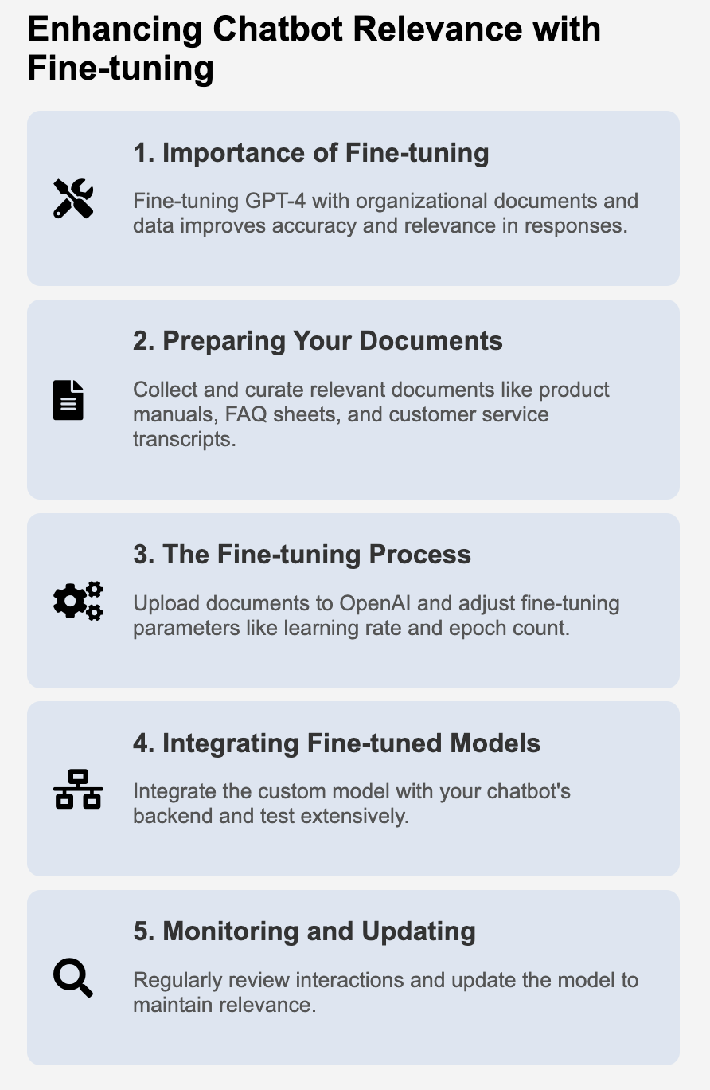

* 1. **Importance of Fine-Tuning**

• **Contextual Relevance:** Fine-tuning GPT-4 with your organization's documents ensures that the chatbot understands and uses the specific terminology, products, and services pertinent to your business.

• **Continuous Improvement**: It allows for the periodic update of the chatbot's knowledge base, ensuring that it remains current and relevant.

* 1. **Preparing Your Documents**

• **Document Collection:** Gather and curate relevant documents, such as product manuals, FAQ sheets, and customer service transcripts, that represent your organization's knowledge base.

• **Data Formatting:** Format the collected data according to OpenAI's guidelines, ensuring a clean and structured dataset that facilitates effective fine-tuning.

* 1. **The Fine-Tuning Process**

• **Dataset Creation:** Compile the cleansed and structured data into a dataset compatible with GPT-4's learning algorithms.

• **Parameter Adjustments:** Learn how to adjust parameters like learning rate and epoch count based on trial runs and performance evaluations to optimize the fine-tuning process.

* 1. **Integrating Fine-Tuned Models**

• **Model Integration:** Once the fine-tuning is complete, integrate the customized model into your chatbot's backend system, replacing or augmenting the standard GPT-4 model to enhance its abilities.

• **Testing:** Conduct extensive testing to ensure that the fine-tuned model meets the expected standards of relevance and accuracy.

* 1. **Monitoring and Updating**

• **Performance Review:** Regularly review the chatbot's performance to identify areas for further improvement.

• **Iterative Enhancements:** Employ an iterative approach to continuously refine the chatbot based on real-world interactions and feedback, aiming for a continually improving system.

6 
Prepare 
Documents 
Upload & Fine- 
tune 
Integrate Model 
Chatbot Testing 
Monitor & Update 

Chapter 7: Preparing Organizational Documents for GPT-4 Fine-Tuning

Optimizing the GPT-4 model to align with your business needs involves the careful preparation of organizational documents. This chapter guides you through the selection, conversion, cleaning, and structuring of documents, setting the stage for successful fine-tuning. Incorporating organizational insights into the GPT-4 chatbot begins with the meticulous preparation of your organizational documents. This chapter provides a concrete plan to select, convert, clean, and structure your documents effectively, setting the stage for successful fine-tuning.

Optimizing GPT-4 with Document 
Preparation 
O Objective 
Clearly define the goals of the fine-tuning process to enhance the chatbot's 
ability to understand and communicate effectively using specific 
organizational terminologies and nuances. 
Document Selection 
• Create criteria for selection that encompass relevance, credibility, and 
currentness of the information. 
• Collaborate with departments to aggregate materials and establish a 
collection process. 
-S Document Conversion 
Deploy tools for converting documents into a consistent format suitable for 
data extraction. 
Data Cleaning 
Develop scripts to automate data cleaning and set up a verification process 
to preserve data integrity. 
Data Structuring 
Develop data models compatible with GPT-4 and conduct tests to ensure 
quality of structured data. 
Tools and Resources 
Allocate resources for collaboration and document management and engage 
with community resources for continuous improvement. 
O Compliance and Security 
Implement data security measures and protocols to safeguard sensitive 
information and prevent data breaches. 
Feedback and Continuous Improvement 
Set up feedback mechanisms and adopt an iterative approach to enhance 
the quality of the prepared data. 

* 1. **Objective**

• Establish the Goals: Clearly define the goals of the fine-tuning process. The primary focus should be to enhance the GPT-4 chatbot's ability to understand and communicate effectively using the specific terminologies and contextual nuances of your organization. The outcome should be a chatbot that can resonate well with the users while adhering to the organizational communication style.

* 1. **Document Selection**

• Criteria for Selection: Create a set of criteria to select the documents that embody the knowledge base of your organization. The criteria should encompass factors such as the relevance of content, the credibility of the source, and the currentness of the information.

• Collaboration with Departments: Forge collaborations with various departments to aggregate materials like product manuals, internal policy documents, and customer feedback. Set clear guidelines for the kind of documents required and establish a streamlined process for collection.

# Tips for Effective Document Selection

- Collaborate with different departments to gather a diverse range of materials.

- Consider setting up a document repository for storing and easily accessing selected materials.

- Establish a review process to ensure the selected documents align with the set criteria.

* 1. **Document Conversion**

• Conversion Tools: Deploy tools to convert different document formats like PDFs and Word documents into a consistent format suitable for data extraction, possibly leveraging models like Anthropic for advanced text extraction.

• Data Extraction Techniques: Implement techniques that focus on extracting valuable data from the documents while retaining the contextual nuances.

* 1. **Data Cleaning**

• Automated Cleaning Techniques: Develop scripts to automate the data cleaning process, focusing on removing inconsistencies and formatting issues that might hinder the fine-tuning process.

• Verification Process: Set up a team to manually verify the cleaned data, ensuring the removal of irrelevant content and the preservation of data integrity.

* 1. **Data Structuring**

• Creating Data Models: Develop data models to facilitate effective data structuring, focusing on creating models that are compatible with the GPT-4 processing capabilities.

• Testing Structured Data: Conduct tests to evaluate the quality of the structured data, making necessary adjustments based on the feedback received.

* 1. **Tools and Resources**

• Resource Allocation: Allocate resources effectively, ensuring the availability of necessary tools and platforms for collaboration and document management.

• Community Engagement: Engage with community resources and forums to seek guidance and collaborate with experts in the field, fostering a culture of knowledge sharing and continuous improvement.

* 1. **Best Practices and Tips**

• Expert Consultation: Seek advice from industry experts to gather insights and tips that can facilitate a smoother document preparation process.

• Roadmap Creation: Create a detailed roadmap outlining the milestones and timelines, keeping the team aligned and focused on the objectives.

* 1. **Compliance and Security**

• Data Security Measures: Implement robust data security measures to safeguard sensitive information during the preparation process, adhering to industry regulations and organizational policies.

• Document Confidentiality: Ensure the confidentiality of sensitive documents during the preparation process, developing protocols to prevent unauthorized access and data breaches.

* 1. **Feedback and Continuous Improvement**

• Feedback Mechanism: Set up mechanisms to gather feedback from team members during the document preparation phase, fostering a culture of continuous improvement.

• Iterative Approach: Adopt an iterative approach to the preparation process, making regular evaluations and adjustments to enhance the quality of the prepared data, geared towards achieving optimal fine-tuning results.

Chapter 8: Initiating the GPT-4 Fine-Tuning Process

Initiating the GPT-4 fine-tuning process is a significant step in the journey to build a responsive and intelligent chatbot. This chapter aims to guide you through a structured approach to kickstart the fine-tuning process, encompassing the creation of datasets, uploading them to the OpenAI platform, and setting appropriate parameters for optimal customization.

* 1. **Objective**

• **Set Clear Goals:** Define specific goals for the fine-tuning process, focusing on enhancing the chatbot's linguistic abilities, improving contextual understanding, or tailoring responses to suit your organizational tone and style.

* 1. **Creating a Dataset**

• **Dataset Compilation:** Compile cleansed and structured data into a coherent dataset, ensuring a balanced mix of data that encompasses a wide range of inputs and scenarios.

• **Data Validation:** Develop scripts to validate the integrity and structure of the data, ensuring readiness for the fine-tuning process.

# Code snippet to validate data structure in a dataset (Python)

import pandas as pd

# Load dataset

data = pd.read\_csv('dataset.csv')

# Validate data structure

if 'input\_column' in data.columns and 'output\_column' in data.columns:

print("Data validation passed")

else:

print("Data validation failed")

* 1. **Uploading the Dataset**

• **Secure Data Transmission:** Establish secure channels to upload the dataset to the OpenAI platform, ensuring data confidentiality and integrity are maintained.

• **Error Handling:** Implement error handling mechanisms to manage potential issues during the data upload process, swiftly identifying and rectifying errors to prevent data loss or corruption.

* 1. **Configuring Fine-Tuning Parameters**

• **Parameter Configuration:** Adjust parameters such as learning rate, number of training epochs, and model version to align with the objectives of the fine-tuning process.

• **Optimization Techniques:** Apply optimization techniques to fine-tune the parameters based on initial results, focusing on achieving desired performance metrics.

# Code snippet to configure fine-tuning parameters (Python)

def configure\_fine\_tuning\_params(params):

# Function to configure fine-tuning parameters

optimized\_params = optimize\_params(params)

return optimized\_params

* 1. **Initiating the Fine-Tuning Process**

• **Process Initiation:** Start the fine-tuning process through the OpenAI platform, utilizing the configured parameters and uploaded dataset to initiate the fine-tuning.

• **Progress Monitoring:** Set up monitoring tools to track the progress of the fine-tuning process, analyzing performance metrics to make informed adjustments if necessary.

* 1. **Evaluating the Model**

• **Validation Dataset:** Utilize a separate validation dataset to assess the performance of the fine-tuned model, focusing on metrics like accuracy, precision, and recall to gauge the effectiveness of the fine-tuning.

• **Performance Analysis:** Conduct a thorough analysis of the performance metrics, drawing insights to make further adjustments and enhancements to the model.

# Code snippet to evaluate model performance (Python)

def evaluate\_model\_performance(model, validation\_data):

# Function to evaluate model performance using validation data

performance\_metrics = model.evaluate(validation\_data)

return performance\_metrics

* 1. **Troubleshooting and Support**

• **Common Issues:** Develop a repository of common issues and their resolutions encountered during the fine-tuning process, facilitating quick resolution of problems.

• **Support Channels:** Establish support channels where team members can seek assistance or guidance during the fine-tuning process, fostering collaborative problem-solving.

GPT-4 Fine-Tuning Process 
O Objective 
Define specific goals for the fine-tuning process, focusing on linguistic 
abilities and organizational context. 
Creating a Dataset 
Compile cleansed and structured data into a coherent dataset, 
ensuring a balanced mix of inputs and scenarios. 
Develop scripts to validate the integrity and structure of the data, 
ensuring readiness for the fine-tuning process. 
# Code snippet to validate data structure in a 
dataset (Python) import pandas as pd # Load 
= pd. read_csv( 'dataset.csv') # 
dataset data 
Validate data structure if input_column' in 
data. columns and 'output_column' in 
data. columns: print ("Data validation passed") 
else: print("Data validation failed") 
Uploading the Dataset 
Establish secure channels to upload the dataset to the OpenAl 
platform, ensuring data confidentiality and integrity. 
Implement error handling mechanisms to manage potential issues 
during the upload process. 
Configuring Fine-Tuning Parameters 
Adjust parameters such as learning rate, number of training epochs, 
and model version to align with the objectives. 
Apply optimization techniques based on initial results to achieve 
desired performance metrics. 
# Code snippet to configure fine—tuning 
parameters (Python) def 
configure_fine_tuning_params(params): # Function 
to configure fine—tuning parameters 
= rams) 
opt imized_pa rams 
return optimized_pa rams 
Initiating the Fine-Tuning Process 
Start the fine-tuning process using the configured parameters and 
uploaded dataset on the OpenAl platform. 
Set up monitoring tools to track the progress and make informed 
adjustments if necessary. 
Evaluating the Model 
Utilize a validation dataset to assess the performance of the fine- 
tuned model on metrics like accuracy and recall. 
# Code snippet to evaluate model performance 
(Python) def evaluate_model_performance(model, 
validation_data): # Function to evaluate model 
performance performance_metrics = 
model. return 
performance_met rics 
O Troubleshooting and Support 
Develop a repository of common issues and their resolutions to 
facilitate quick problem-solving. 
Establish support channels for team members to seek assistance 
during the fine-tuning process. 

Chapter 9: Incorporating the Fine-Tuned Model into Your Chatbot

As you approach the final stages of fine-tuning the GPT-4 model, the next critical step is the seamless integration of this fine-tuned model into your chatbot. This chapter delineates a structured strategy to achieve this, emphasizing backend preparation, API modification, and robust testing methodologies to ensure a smooth transition and an enhanced user experience.

* 1. **Objective**

• **Define Integration Goals:** Clearly articulate the specific goals for the integration phase, focusing on enhancing user interactions by leveraging the fine-tuned GPT-4 model's improved linguistic and contextual understanding capabilities.

* 1. **Integration Preparation**

• **Backend Readiness:** Ensure the chatbot's backend system is primed to accommodate the fine-tuned model. This involves necessary configuration changes and potential system upgrades to support new functionalities.

• **Team Collaboration:** Facilitate collaboration between different teams involved in the integration process, ensuring a cohesive approach to achieving the integration goals.

* 1. **Updating API Calls**

• **Modifying API Parameters:** Implement necessary modifications in the existing API calls to incorporate the fine-tuned model. This includes updating the model ID parameter and adjusting API endpoints as needed.

• **Error Handling:** Develop mechanisms for effective error handling during API integration, swiftly identifying and rectifying issues to ensure uninterrupted operation.

# Code snippet to demonstrate modifying API calls (Python)

import openai

def modify\_api\_calls(new\_model\_id):

openai.api\_key = 'your-secured-api-key-here'

response = openai.Completion.create(

engine=new\_model\_id,

prompt="Your prompt here", max\_tokens=50

)

return response

* 1. **Response Handling**

• **Response Processing:** Adapt the response processing logic in your backend to handle potential changes in the response formats or structures from the fine-tuned model.

• **User Interface Adjustments:** Make necessary adjustments in the user interface to accommodate new response styles or data formats, ensuring a seamless user experience.

* 1. **Testing Post-Integration**

• **Functional Testing:** Conduct functional testing to verify that the integration works as expected, validating the functionalities and ensuring compatibility with existing systems.

• **User Acceptance Testing:** Organize user acceptance testing to evaluate the real-world performance of the chatbot with the fine-tuned model, gathering user feedback on the quality of interactions.

# Code snippet to demonstrate functional testing (Python)

def functional\_testing(test\_cases, chatbot\_function):

test\_results = []

for test\_case in test\_cases:

result = chatbot\_function(test\_case['input'])

if result == test\_case['expected\_output']:

test\_results.append('Pass')

else:

test\_results.append('Fail')

return test\_results

* 1. **Performance Monitoring**

• **Monitoring Tools**: Implement monitoring tools to track the chatbot's performance post-integration, focusing on metrics like response time and user engagement levels to identify areas for improvement.

• **Feedback Integration:** Establish channels to integrate user feedback into the continuous improvement process, leveraging insights from real-world interactions to refine the chatbot further.

* 1. T**raining and Support**

• **Training Sessions:** Conduct training sessions to equip team members with knowledge on the new features and functionalities, ensuring efficient usage and troubleshooting.

• **Support Channels**: Set up support channels where team members can seek assistance or report issues encountered during the post-integration phase, facilitating collaborative problem-solving.

* 1. **Documentation Update**

• **Updating Documentation:** Update the existing documentation to reflect the changes made during the integration process, providing team members with accurate and up-to-date information.

• **Version Control:** Implement version control for the documentation, tracking changes and updates effectively to maintain a reliable source of reference.

* 1. **User Engagement and Feedback**

• **User Engagement Strategies:** Develop strategies to actively engage users post-integration, encouraging them to explore and utilize the enhanced features of the chatbot.

• **Feedback Mechanism:** Establish a user feedback mechanism to gather insights on user satisfaction and areas where the chatbot can be further improved, fostering a cycle of continuous improvement.

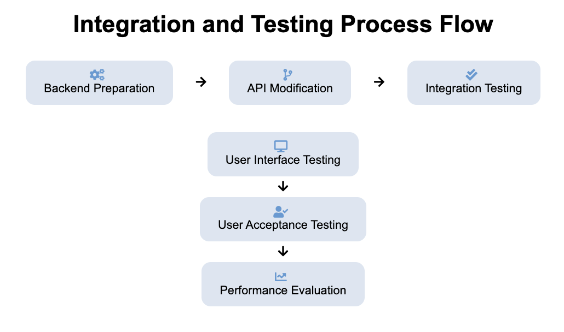

Chapter 10: Enhancing Chatbot Capabilities with Document Uploads

Enabling your GPT-4 powered chatbot to accept and process document uploads from users can significantly enhance its utility and efficiency. This chapter guides you through the structured steps to implement this feature, focusing on frontend setup, backend configuration, and ensuring a seamless user experience with document data integration.

* 1. **Objective**

• **Define the Enhancement Goals:** Set explicit objectives for incorporating document upload capabilities, focusing on enhancing data processing and offering personalized responses based on the content of uploaded documents.

* 1. **Front-End Setup**

• **User Interface Implementation:** Design a user interface that allows for easy document uploads. Implement functionalities such as drag-and-drop or file selection dialog boxes to facilitate user-friendly document uploads.

• **File Type Restrictions:** Specify the types of files that can be uploaded, such as PDFs, Word documents, or Excel files, and implement restrictions to prevent the upload of unsupported file types.

<!-- HTML snippet to create a file upload button with specified accepted file types -->

<input type="file" id="docUpload" name="docUpload" accept=".pdf, .doc, .docx, .xlsx">

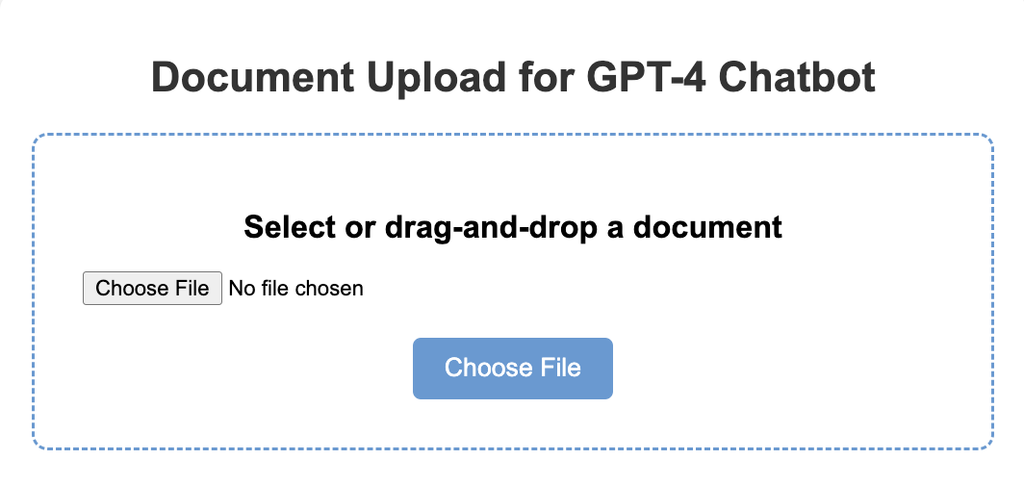

* 1. **Backend Configuration**

• **Service Development:** Develop backend services capable of receiving and securely storing the uploaded files. Implement functionalities to validate the uploaded files, checking for potential issues such as file size limits or unsupported formats.

• **Data Parsing and Extraction:** Create scripts to parse the uploaded documents, extracting text and data for further processing by the chatbot.

# Python snippet to demonstrate backend configuration for handling file uploads using Flask

from flask import Flask, request

app = Flask(\_\_name\_\_)

@app.route('/upload', methods=['POST'])

def upload\_file():

uploaded\_file = request.files['document']

if uploaded\_file.filename != '':

uploaded\_file.save(uploaded\_file.filename)

return 'File uploaded successfully'

if \_\_name\_\_ == '\_\_main\_\_':

app.run()

* 1. **Processing Uploaded Documents**

• **Document Parsing:** Implement parsing techniques to extract text or data from uploaded documents, converting different file formats into a structured format that can be processed by the GPT-4 model.

• **OCR Implementation:** Incorporate Optical Character Recognition (OCR) techniques for processing image-based or scanned documents, converting them into text for further analysis by the chatbot.

* 1. **Integrating with GPT-4**

• **Data Integration:** Develop methods to integrate the extracted data from documents into the GPT-4 model, utilizing this data as part of the conversation context or as direct queries to generate responses.

• **Contextual Response Generation**: Enhance the chatbot's ability to generate responses based on the data extracted from the uploaded documents, focusing on maintaining coherence and contextual relevance.

* 1. **Response and Storage**

• **Response Presentation:** Develop strategies for effectively presenting the chatbot's responses to uploaded documents in the user interface, focusing on clarity and engagement.

• **Data Storage Compliance:** Ensure adherence to data privacy regulations for storing and handling user-uploaded documents, implementing secure storage solutions and compliance checks.

* 1. **User Engagement and Support**

• **User Guidance:** Create detailed user guidance material to assist users in effectively utilizing the document upload feature, including step-by-step instructions and FAQs.

• **Support Mechanisms:** Establish support mechanisms where users can seek assistance or report issues related to document uploads, fostering a supportive user experience.

* 1. **Continuous Improvement**

• **Feedback Integration**: Set up channels to gather user feedback on the document upload feature, utilizing the feedback to make continuous improvements.

• **Performance Metrics:** Implement tools to monitor the performance of the document upload feature, focusing on metrics such as user engagement levels and response accuracy to guide further enhancements.

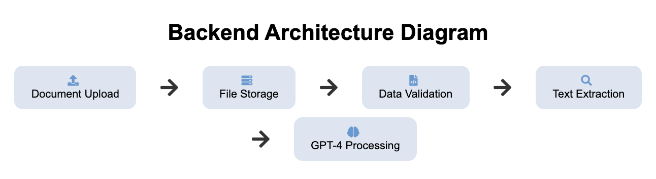

Chapter 11: Integrating Document Data with GPT-4 for Informed Responses

Taking your GPT-4 powered chatbot to the next level involves the integration of document data into the chatbot's response mechanism, enhancing its ability to provide informed and contextual responses. This chapter guides you through a series of structured steps to seamlessly integrate data from uploaded documents into the chatbot's conversation flow, leveraging advanced AI models for document insight integration.

* 1. **Objective**

• **Set Specific Goals:** Define the specific objectives of integrating document data into the chatbot, with a focus on enhancing the chatbot’s ability to provide informed and contextual responses based on the data derived from the uploaded documents.

* 1. **Data Extraction and Formatting**

• **Advanced Text Extraction:** Implement advanced text extraction techniques, possibly leveraging models like Anthropic, to interpret and structure data from various document formats.

• **Data Formatting Standards:** Establish data formatting standards that facilitate the seamless integration of extracted data into the GPT-4 processing pipeline.

* 1. **Augmenting GPT-4 with Anthropic**

• **Integration with Anthropic:** Explore the integration of Anthropic models to augment GPT-4’s text processing capabilities, focusing on enriching the chatbot’s responses with nuanced understanding and improved accuracy.

• **Response Enhancement:** Develop methods to utilize the insights processed by Anthropic to enhance the responses generated by GPT-4, ensuring that the responses are informed by a deep understanding of the document content.

* 1. **Update Conversation Context**

• **Context Management**: Develop strategies for effective context management, combining structured data from documents with the existing conversation context to provide more informed responses.

• **Contextual Relevance:** Implement techniques to ensure that the document data integrated into the conversation context maintains relevance and coherence, enhancing the user experience.

* 1. **Tailor GPT-4 Prompts**

• **Prompt Customization:** Customize the prompts sent to GPT-4 to incorporate insights derived from document data, focusing on generating responses that are both informative and contextually relevant.

• **Dynamic Prompt Generation:** Develop a dynamic prompt generation system that can adapt based on the nature of the document data being integrated, ensuring flexibility and adaptability in response generation.

# Python snippet to demonstrate dynamic prompt generation based on document data

def generate\_dynamic\_prompt(document\_data):

# Analyze document data to determine the appropriate prompt

if 'policy' in document\_data['category']:

prompt = "Generate a policy-compliant response based on the following information: "

else:

prompt = "Generate a general response based on the following information: "

prompt += document\_data['extracted\_text']

return prompt

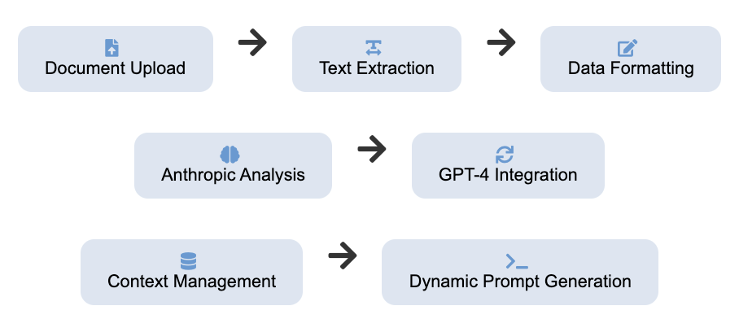

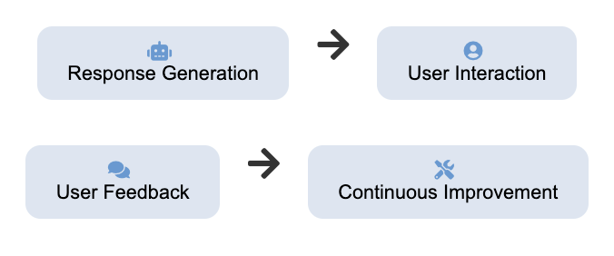

* 1. **Validate and Enhance Responses**

• **Response Validation Loop:** Create a validation loop where responses informed by document data are assessed for accuracy and relevance, making necessary adjustments to enhance the quality of interactions.

• **Continuous Improvement:** Foster a culture of continuous improvement, utilizing feedback and performance metrics to make data-driven enhancements to the chatbot’s capabilities.

* 1. **User Confirmation and Engagement**

• **User Confirmation:** Integrate mechanisms to involve users in the validation process, encouraging them to confirm the accuracy and relevance of the chatbot's responses, fostering user engagement.

• **Feedback Loop:** Establish a feedback loop where user inputs are utilized to further refine and enhance the chatbot’s understanding and response generation capabilities, promoting a cycle of continuous improvement.

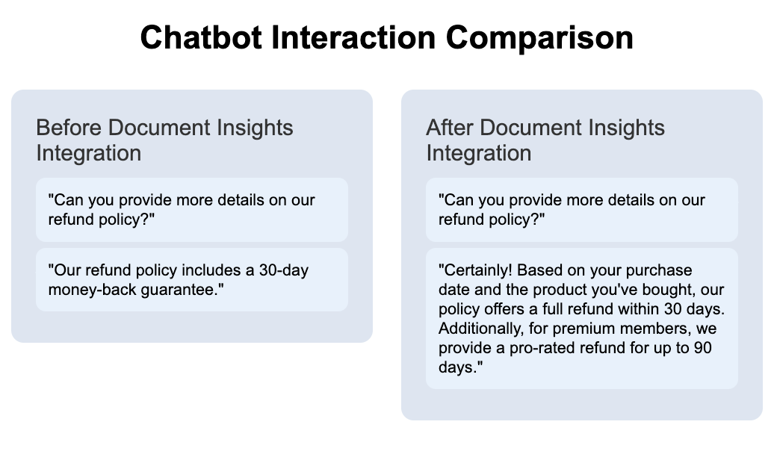

Chapter 12: Validating Chatbot Responses Informed by Uploaded Documents

The validation of chatbot responses, especially those informed by user-uploaded documents, is a critical aspect to ensure the accuracy and reliability of the chatbot. This chapter unfolds a systematic approach to implementing a robust validation system that continuously assesses the quality of chatbot responses, involving users in the process to enhance the chatbot's performance over time.

* 1. **Objective**

• **Establish Validation Goals:** Clearly set the objectives of the validation process, focusing on maintaining the accuracy and reliability of the chatbot responses, especially those influenced by the data extracted from uploaded documents.

* 1. **Establish Validation Criteria**

• **Criteria Development:** Develop stringent criteria that define what constitutes a valid response, considering the context provided by the uploaded documents and the user's original query.

• **Automated Validation Checks:** Implement automated checks to compare the chatbot's responses against the established criteria, flagging responses that may require further review or adjustment.

# Python snippet to demonstrate automated validation checks

def validate\_response(response, criteria):

if all(criterion in response for criterion in criteria):

return "Valid Response"

else:

return "Invalid Response"

* 1. **Response Correction Mechanism**

• **Correction Strategies:** Formulate strategies to correct flagged responses, using contextual clues or manual intervention by a human overseer to adjust the responses appropriately.

• **Correction Implementation:** Implement the correction mechanisms, ensuring that the adjustments made align with the validation criteria and enhance the response quality.

* 1. **Feedback Loop for Continuous Learning**

• **Feedback Integration:** Integrate a feedback system that utilizes the outcomes of the validation process as learning inputs for the chatbot, enabling it to improve its ability to provide accurate responses based on uploaded document data.

• **Continuous Improvement Cycle:** Establish a cycle of continuous improvement, where the chatbot learns and adapts from the feedback, making iterative refinements to its response generation mechanisms.

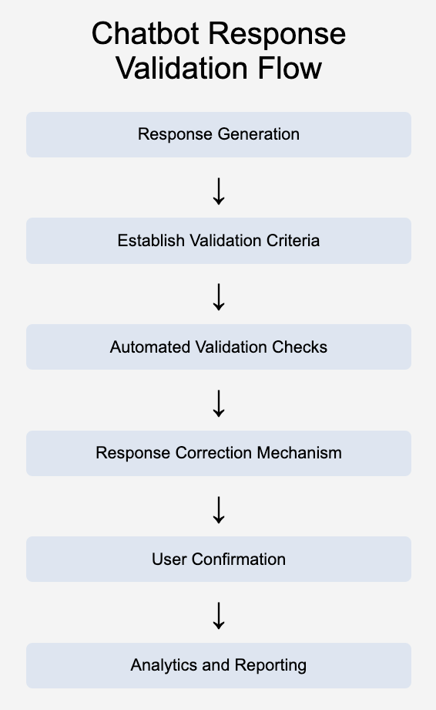

* 1. **User Confirmation**

• **User Involvement:** Create avenues to involve users in the validation process, encouraging them to confirm the accuracy and relevance of the chatbot's responses, adding a layer of human verification to the validation process.

• **User Feedback Integration:** Develop mechanisms to collect and integrate user feedback into the validation process, utilizing user insights to make further improvements to the chatbot's performance.

# Python snippet to demonstrate user feedback integration

def integrate\_user\_feedback(response\_id, user\_feedback):

# Logic to integrate user feedback into the validation process

if user\_feedback == "Incorrect Response":

# Logic to flag response for review and correction

return "Feedback Integrated"

* 1. **Analytics and Reporting**

• **Performance Metrics:** Implement tools to analyze the performance metrics of the validation process, focusing on aspects such as response accuracy rate and user satisfaction levels.

• **Reporting:** Develop reporting mechanisms to regularly review the performance metrics, using the insights to guide strategic decisions for further improvements to the chatbot.

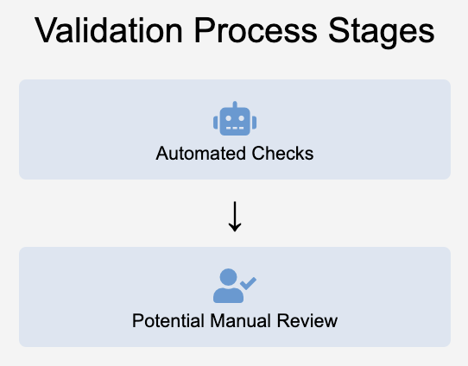

Chapter 13: Streamlining Chatbot Conversations with Document Data

To enhance the user experience, it's essential to streamline the chatbot's interactions by effectively incorporating insights from uploaded documents into the conversation. This chapter delineates the methods to optimize the chatbot's response generation process, focusing on contextual relevance, response optimization, and user experience enhancements to foster engaging and insightful conversations.

* 1. **Objective**

• **Define Enhancement Objectives:** Specify the goals for streamlining chatbot conversations, emphasizing the utilization of insights from uploaded documents to foster enriched and contextually relevant interactions.

* 1. **Contextual Relevance**

• **Context Management:** Develop strategies to ensure that the information extracted from documents is contextually relevant to the ongoing conversation, enhancing the chatbot's ability to provide insightful responses.

• **Algorithm Development:** Create algorithms that efficiently match user queries with the appropriate data extracted from documents, ensuring a seamless integration of document data into the conversation flow.

* 1. **Response Generation Optimization**

• **Response Structuring:** Formulate methods to optimize the structuring of responses, focusing on presenting document-derived information in a coherent and user-friendly manner.

• **Dynamic Response Generation:** Develop a dynamic response generation system that can adapt based on the nature of the document data being integrated, ensuring flexibility in response generation.

# Python snippet to demonstrate dynamic response generation based on document data

def generate\_dynamic\_response(document\_data, user\_query):

# Logic to generate a dynamic response based on document data and user query

response = "Generated response based on document data and user query"

return response

* 1. **User Experience Considerations**

• **User Interface Adjustments:** Make necessary adjustments to the user interface to facilitate a seamless display of responses that incorporate document data, ensuring clarity and engagement.

• **Interactive Elements:** Integrate interactive elements into the chatbot's responses, offering users an enriched experience when interacting with document-derived information.

* 1. **Performance Metrics**

• **Monitoring Tools:** Implement monitoring tools to track performance metrics specific to interactions based on uploaded documents, focusing on aspects such as user satisfaction and the relevance of the chatbot's responses.

• **Metrics Analysis:** Conduct regular analyses of the performance metrics, using the insights to guide further refinements and improvements to the chatbot's capabilities.

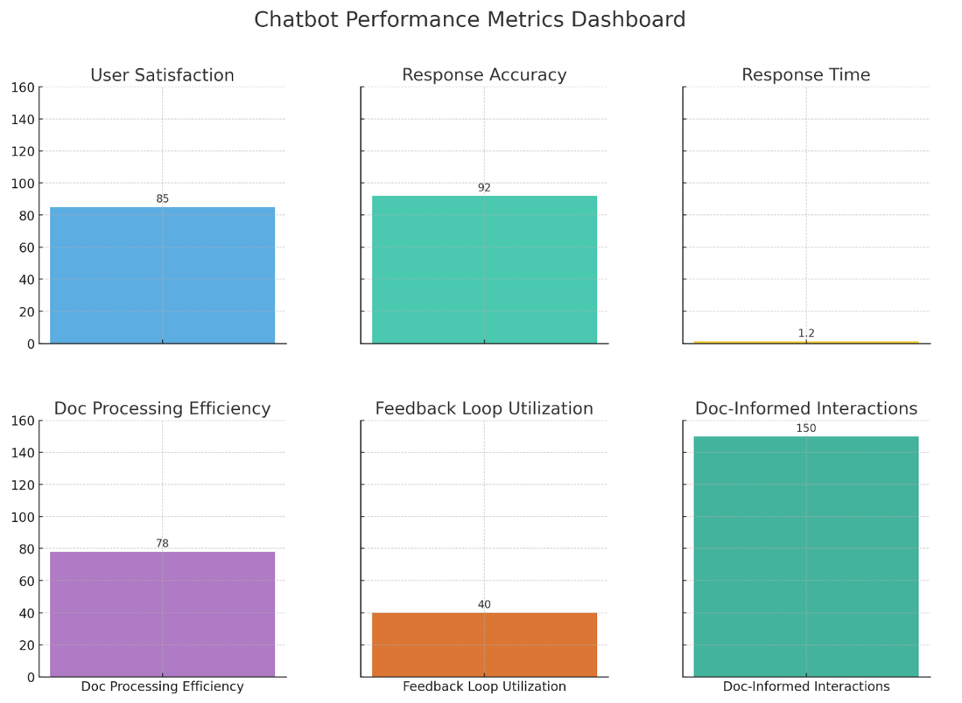

* 1. **Iterative Refinement**

• **Feedback Loop:** Establish a feedback loop that integrates user feedback and observed interaction patterns into the continuous improvement process, fostering a cycle of iterative refinements to enhance the chatbot's performance.

• **Enhancement Strategies:** Develop strategies to make ongoing improvements to how the chatbot utilizes document data, focusing on enhancing the relevance and contextual understanding of the chatbot.

* 1. **Training and Knowledge Transfer**

• **Team Training:** Organize training sessions for team members to ensure they are well-acquainted with the new functionalities and can effectively manage and enhance the chatbot's capabilities.

• **Knowledge Transfer**: Facilitate knowledge transfer sessions where team members can share insights and learnings, promoting a collaborative approach to chatbot enhancement.

Chapter 14: Enhancing User Experience in Document-Enhanced Chatbot Interactions

To ensure that users have a seamless and engaging experience while interacting with a document-enhanced chatbot, it's vital to focus on user-centric design and functionalities. This chapter guides you through various strategies to craft user-centric interactions that effectively leverage document insights, ensuring a harmonious blend of AI capabilities and user-friendly design.

* 1. **Objective**

• **Establishing User-Centric Goals**: Define clear objectives focusing on enhancing the user experience by crafting interactions that are intuitive, engaging, and informed by document data insights.

* 1. **Simplify Data Presentation**

• **Data Simplification:** Implement methods to present document-derived information in a simplified and digestible manner. Avoid complex jargons and present data in a way that is easy to understand and interact with.

• **Visual Representation:** Introduce visual elements, such as charts or graphs, where relevant, to represent document data in a more user-friendly manner, facilitating easier comprehension.

* 1. Interactive Response Elements

• **Interactive Components:** Integrate interactive components like buttons or clickable elements within the chatbot responses to facilitate user interaction with document-derived data, offering a dynamic and engaging user experience.

• **Guided Navigation:** Develop functionalities that guide users in navigating complex information derived from documents, such as collapsible sections for detailed data or quick links to related topics.

# Python snippet to demonstrate creation of interactive response elements (conceptual)

def create\_interactive\_response(document\_data):

# Logic to create a response with interactive elements based on document data

interactive\_response = {

"text": "Here is the information based on the uploaded document:",

"interactive\_elements": [

{"type": "button", "label": "More Details", "action": "show\_more\_details"},

{"type": "link", "label": "Related Topic", "url": "<http://example.com/related_topic>"}

],

"visual\_representation": "link\_to\_chart\_or\_graph"

}

return interactive\_response

* 1. **Personalized Responses**

• **Personalization Strategies:** Develop strategies to personalize responses based on user profiles and previous interactions, offering a more tailored and engaging experience.

• **Contextual Personalization:** Implement functionalities to offer personalized suggestions or responses based on the context derived from the uploaded documents, enhancing the relevance of interactions.

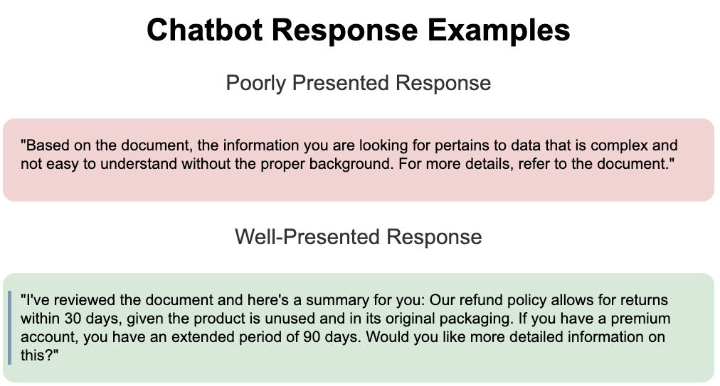

* 1. **Clarification and Follow-Up**

• **Clarification Queries:** Design the chatbot to proactively ask clarification questions if the user’s query seems ambiguous, especially when dealing with complex document data, ensuring the generation of more accurate responses.

• **Follow-Up Mechanisms:** Implement mechanisms to offer follow-up options or additional information based on user responses, fostering an interactive and engaging conversation flow.

* 1. **User Feedback Collection**

• **Feedback Channels:** Establish channels to collect user feedback on the document-enhanced interactions, aiming to gather insights on user satisfaction and areas for improvement.

• **Feedback Analysis:** Develop tools to analyze user feedback, utilizing the insights to make data-driven improvements to the chatbot’s functionalities and user experience.

# Python snippet to demonstrate user feedback collection (conceptual)

def collect\_user\_feedback(interaction\_id, user\_feedback):

# Logic to collect and store user feedback on specific interactions

feedback\_database[interaction\_id] = user\_feedback

return "Feedback collected successfully"

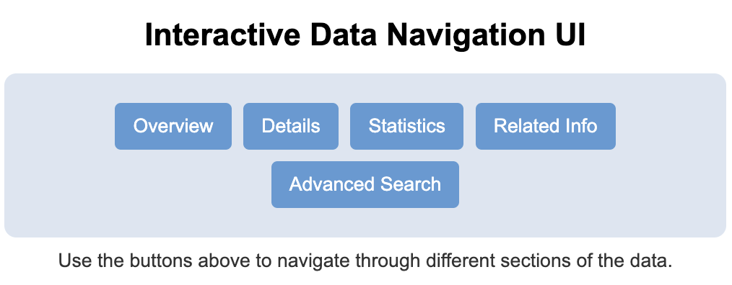

* 1. **Scalability Considerations**

• **Scalable Design:** Focus on designing the chatbot to handle a growing number of users and document uploads seamlessly, ensuring a consistent user experience.

• **Infrastructure Enhancement:** Consider infrastructure enhancements to support scalability, such as implementing load balancing and optimizing data processing pipelines to handle increased loads efficiently.

Chapter 15: Deploying Your Document-Enhanced Chatbot

Deploying your document-enhanced chatbot marks a significant milestone in the journey to offering users a more enriched and insightful interaction experience. This chapter outlines concrete steps and considerations to ensure a successful deployment, focusing on pre-deployment preparations, choosing the right platform, and optimizing performance post-deployment.

* 1. **Objective**

• **Define Deployment Goals:** Clearly state the objectives of the deployment phase, which should primarily focus on ensuring a smooth and successful launch of the document-enhanced chatbot, with minimal disruptions and optimal performance.

* 1. **Pre-Deployment Checklist**

• **Integration Verification:** Verify that all integrations, including the document upload and data processing functionalities, are functioning as expected, ensuring a seamless user experience post-deployment.

• **Security Review:** Conduct a thorough security review to safeguard user data, especially sensitive information extracted from documents, adhering to industry standards and regulatory requirements.

* 1. **Choose a Deployment Platform**

• **Platform Selection:** Select a cloud platform that offers robust scalability and security features. Consider platforms known for supporting AI and machine learning workloads, such as AWS, Google Cloud, or Azure.

• **Platform Configuration:** Configure the selected platform to handle the expected user load, setting up necessary components like databases, APIs, and storage solutions in alignment with the platform’s best practices.

* 1. **Set Up Your Deployment Environment**

• **Environment Configuration:** Configure the deployment environment to accommodate the chatbot's requirements, setting up elements like load balancers and auto-scaling functionalities to manage user loads efficiently.

• **Disaster Recovery Plan:** Develop a disaster recovery plan to ensure business continuity in case of system failures, outlining strategies for data backup and system restoration.

# Python snippet to demonstrate a basic configuration setup (conceptual)

class DeploymentConfig:

def \_\_init\_\_(self):

self.load\_balancer\_setup = True

self.auto\_scaling\_setup = True

self.data\_backup\_strategy = "daily\_backup"

def configure\_environment(self):

# Logic to configure the deployment environment with the defined settings

return "Deployment environment configured successfully"

* 1. **Monitor and Optimize Performance**

• **Performance Monitoring:** Implement monitoring tools to track the chatbot's performance in real-time, identifying any bottlenecks or issues that may arise post-deployment.

• **Optimization Strategies:** Develop strategies to optimize the chatbot based on collected performance data, focusing on enhancing user experience and ensuring smooth operations during peak traffic periods.

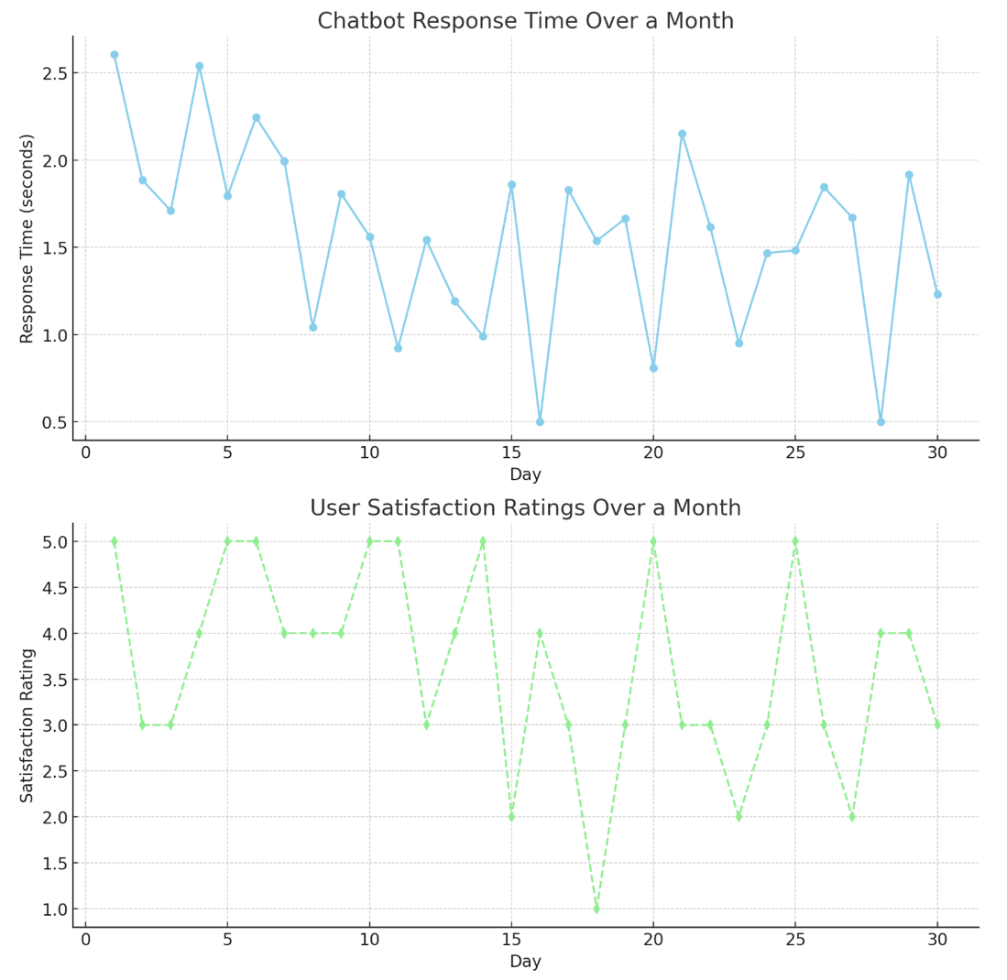

* 1. **User Engagement and Feedback**

• **User Engagement Plan:** Develop a plan to actively engage users post-deployment, encouraging them to explore the enhanced functionalities of the chatbot and provide feedback.

• **Feedback Integration:** Set up mechanisms to collect and analyze user feedback, using the insights to make iterative improvements to the chatbot’s functionalities and performance.

# Python snippet to demonstrate feedback integration (conceptual)

def integrate\_user\_feedback(feedback\_data):

# Logic to integrate user feedback for analysis and improvements

feedback\_database.store(feedback\_data)

return "User feedback integrated successfully"

* 1. **Continuous Improvement Cycle**

• **Improvement Strategies:** Formulate strategies for continuous improvement, focusing on utilizing user feedback and performance metrics to guide refinements.

• **Agile Development Cycle:** Adopt an agile development cycle that allows for quick adaptations and improvements, fostering a culture of continuous enhancement and user-centric focus.

Chapter 16: Continuous Improvement of Your Document-Enhanced Chatbot

Embarking on a journey of continuous improvement is vital to keep your document-enhanced chatbot aligned with evolving user expectations and organizational goals. This chapter guides you through the strategies to establish a cycle of continuous improvement, focusing on performance monitoring, user feedback integration, and iterative enhancements to foster a chatbot that continually evolves to offer enriched user experiences.

* 1. **Objective**

• **Set Improvement Goals:** Establish clear goals for the continuous improvement cycle, focusing on enhancing the chatbot's performance and user satisfaction over time through iterative refinements.

* 1. **Establish Key Metrics**

• **Metrics Identification:** Identify key performance indicators (KPIs) that are vital to monitor the chatbot's performance, such as response accuracy, user engagement levels, and feedback on document-informed interactions.

• **Metrics Tracking Tools:** Implement tools to track these KPIs effectively, setting up dashboards or reporting systems that offer real-time insights into the chatbot's performance.

# Python snippet to demonstrate setting up metrics tracking (conceptual)

class MetricsTracking:

def \_\_init\_\_(self):

self.kpi\_list = ["response\_accuracy", "user\_engagement", "feedback\_analysis"]

def track\_metrics(self, interaction\_data):

# Logic to track metrics based on interaction data

metrics\_data = self.analyze\_data(interaction\_data)

return metrics\_data

* 1. **Collect and Analyze Data**

• **Data Collection Strategies:** Develop strategies to collect data on various aspects of chatbot interactions, focusing on gathering insights that can guide improvements.

• **Data Analysis Tools:** Utilize data analysis t ools to derive meaningful insights from the collected data, analyzing patterns and trends to identify areas for improvement.

* 1. **User Feedback Mechanism**

• **Feedback Collection:** Implement a system to collect feedback from users, focusing on gathering insights on user satisfaction and areas where the chatbot can be further enhanced.

• **Feedback Analysis:** Develop methods to analyze user feedback, utilizing the insights to make data-driven improvements to the chatbot's functionalities.

* 1. **Iterate Based on Insights**

• **Iterative Development:** Adopt an iterative development approach, utilizing the insights from data analysis and user feedback to make targeted improvements to the chatbot.

• **Rapid Prototyping**: Implement rapid prototyping techniques to quickly develop and test improvements, fostering a fast-paced cycle of enhancements.

* 1. **Update and Test**

• **Update Strategies:** Develop strategies for implementing updates to the chatbot, ensuring that new features or refinements are integrated seamlessly without disrupting the user experience.

• **Testing Post-Update:** Conduct thorough testing post-update to verify that the new features or refinements are functioning as expected and are offering improved user experiences.

* 1. **Training and Knowledge Sharing**

• **Team Training:** Organize regular training sessions for the team to stay updated with the latest enhancements and to foster skill development.

• **Knowledge Sharing Sessions:** Facilitate knowledge sharing sessions where team members can share insights and learnings, promoting a collaborative environment and collective growth.

